Web Development Journal

Types Of JavaScript

1. Inline JavaScript
2. Internal JavaScript
3. External JavaScript

1. Inline JavaScript

<!DOCTYPE html>
<html lang="en">
<head>
<meta charset="UTF-8">
<meta name="viewport" content="width=device-width, initial-scale=1">
<title>Happy Birthday</title>
</head>
<body>
<p id="output"></p>
<button id="login" onclick="alert('Lets Start')">Inline</button>
</body>
</html>

Output:

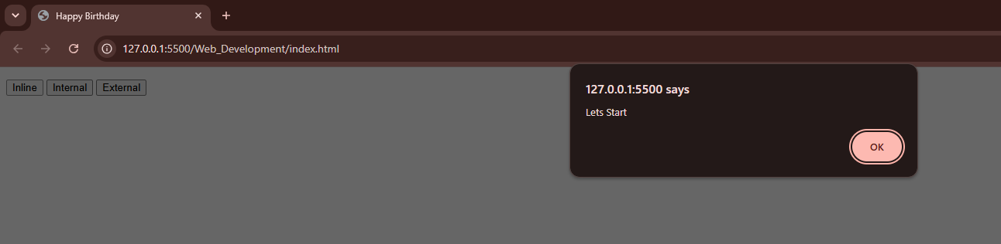

2. Internal JavaScript

<!DOCTYPE html>
<html lang="en">
<head>
<meta charset="UTF-8">
<meta name="viewport" content="width=device-width, initial-scale=1">
<title>Happy Birthday</title>
<script>
function wishme() {
alert("Happy Birthday!")
}
</script>
</head>
<body>
<p id="output"></p>
<button id="login" onclick="wishme()">Internal</button>
</body>
</html>

Output:

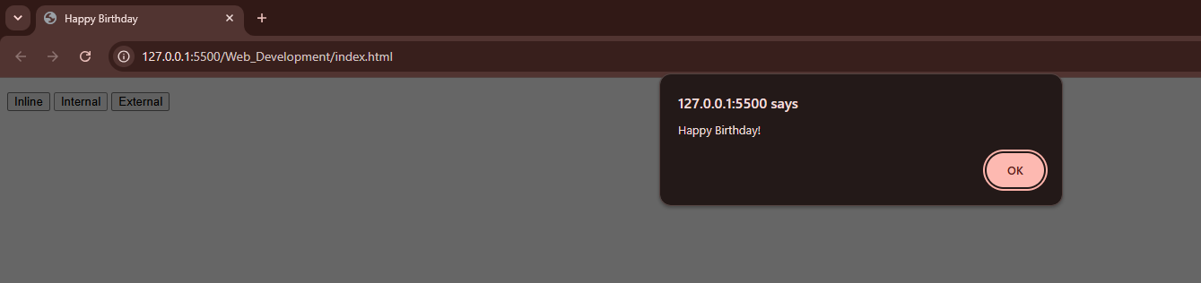

3. External JavaScript

<!DOCTYPE html>
<html lang="en">
<head>
<meta charset="UTF-8">
<meta name="viewport" content="width=device-width, initial-scale=1">
<title>Happy Birthday</title>
<script src="./index.js"></script>
</head>
<body>
<p id="output"></p>
<button onclick="ejs()">External</button>
</body>
</html>

index.js:
function ejs() {
console.log("Hello World!");
alert("Hello From External");
}

Output:

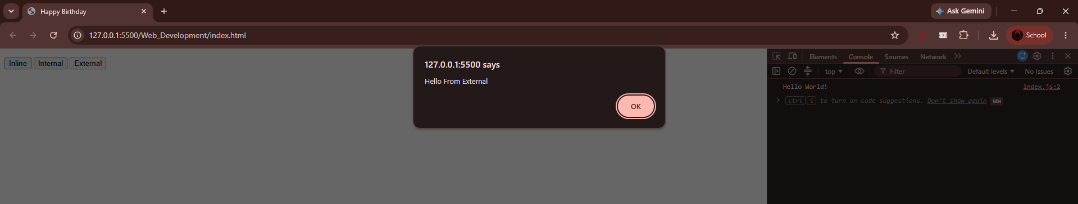

Types Of CSS

1. Inline CSS
2. Internal CSS
3. External CSS

1. Inline CSS

<!DOCTYPE html>
<html lang="en">
<head>
<meta charset="UTF-8">
<meta name="viewport" content="width=device-width, initial-scale=1.0">
<title>Hello</title>
</head>
<body>
<h1 style="color: blue; text-transform: capitalize; border: 1px solid #000;">inline css</h1>
<br>
</body>
</html>

Output:

2. Internal CSS

<!DOCTYPE html>
<html lang="en">
<head>
<meta charset="UTF-8">
<meta name="viewport" content="width=device-width, initial-scale=1.0">
<title>Hello</title>
<style>
a {
background: aquamarine;
font-size: 27px;
font-weight: 600;
color: black;
padding: 5px;
border-radius: 11px;
border: 1.5px solid;
}
</style>
</head>
<body>
<a>Internal Css</a>
</body>
</html>

Output:

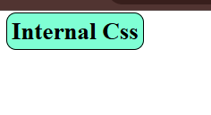

3. External CSS

<!DOCTYPE html>
<html lang="en">
<head>
<meta charset="UTF-8">
<meta name="viewport" content="width=device-width, initial-scale=1.0">
<title>Hello</title>
<!-- <link rel="stylesheet" href="./CSS/index.css"> -->
</head>
<body>
<!-- External CSS -->
<!-- <p>External Css</p> -->
</body>
</html>

index.css:

* {
margin: 0;
padding: 11px;
box-sizing: border-box;
}
p {
color: yellow;
font-size: xx-large;
background-color: red;
font-weight: 700;
border: 2px solid #000;
}

Output:

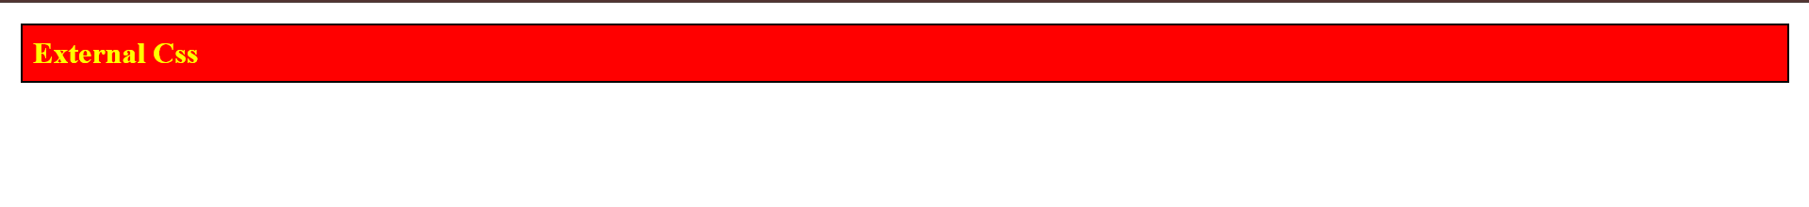

Hoisting

1. let hoisting is not supported

<!DOCTYPE html>
<html lang="en">
<head>
<script>
//1. Let hoisting is not supported
console.log("a= ", a);
let a = "Hello";
</script>
</head>
<body>
</body>
</html>

Output:

2. const hoisting is not supported

<!DOCTYPE html>
<html lang="en">
<head>
<script>
//2. Const hoisting is not supported
console.log("a= ", a);
const a = "Hello";
</script>
</head>
<body>
</body>
</html>

Output:

3. var hoisting is supported

<!DOCTYPE html>
<html lang="en">
<head>
<script>
//3. Var hoisting is supported
console.log("a= ", a);
var a = "Hello";
</script>
</head>
<body>
</body>
</html>

Output:

Functions:

Types Of Functions:
1. Function Declaration
2. Function Expression
3. Arrow Function
3.1 Arrow Function With Multiple Parameters
3.2 Arrow Function With Single Parameters
4. Parameterized Function
5. Immediately Invoked/ Self-Revoking Function
6. Default Parameterized Function
7. Generic Function
8. Constructor Function
8.1 Constructor Function – Variation 2
9. High Order Function
10. Generator Function
11. Callback Function
11.1 Callback Function – Variation 2
12. Async Function

1. Function Declaration

<!DOCTYPE html>
<html lang="en">
<head>
<script>
//1. Function Declaration
function wishFD() {
console.log("This Is Function Declaration");
}
wishFD();
</script>
</head>
<body>
</body>
</html>

Output:

2. Function Expression

<!DOCTYPE html>
<html lang="en">
<head>
<script>
//2. Function Expresssion
var wishFE = function () {
console.log("This Is Function Expression");
}
wishFE();
</script>
</head>
<body>
</body>
</html>

Output:

3. Arrow Function

<!DOCTYPE html>
<html lang="en">
<head>
<script>
//3. Arrow Function
let wishAF = () => {
console.log("This Is Arrow Function");
}
wishAF();
//3.1 Arrow Function With Multiple Parameters
var wishCF = (num1, num2) => {
return num1 + num2;
}
//3.2 Arrow Function With Single Parameter
const wishSF = x => x * x;
</script>
</head>
<body>
<button onclick="alert(wishSF(5)),console.log('This Single Parameterized');
">Single Parameterized Function</button><br><br>
<button onclick="alert(wishCF(1,5)),console.log('This Parameterized');
">Call Parameterized Function</button>
</body>
</html>

Output:

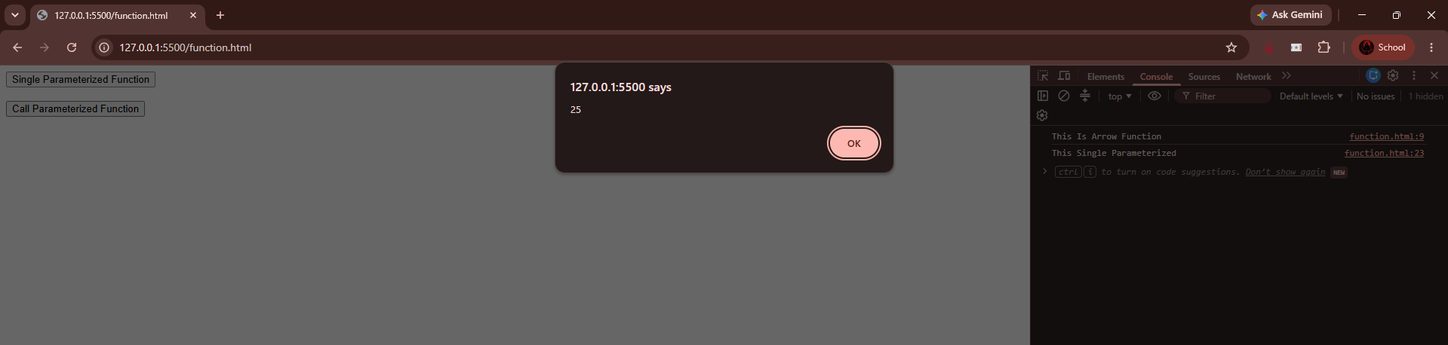
3.2 Single Parameter

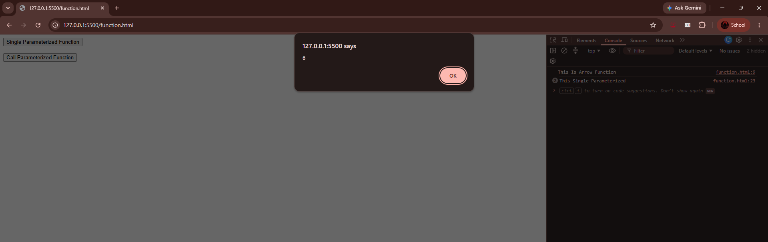
3.1 Multiple Parameter

Normal Arrow Function

4. Parameterized Function

<!DOCTYPE html>
<html lang="en">
<head>
<script>
//4. Parameterized Function
function wishParams(name, greetings) {
console.log("Name: ", name, "Greeting: ", greetings);
}
</script>
</head>
<body>
<button onclick="wishParams('MCAFY','Good Morning')">Call Parameterized Function</button>
</body>
</html>

Output:

5. Immediately Invoked/ Self-Revoking Function

<!DOCTYPE html>
<html lang="en">
<head>
<script>
//5. Immediately Invoked/ Self-Revoking Function
(function () {
console.log("This Is Slef-Revoking Function");
}());
// Syntax
// (function(){}());
</script>
</head>
<body>
</body>
</html>

Output:

6. Default Parameterized Function

<!DOCTYPE html>
<html lang="en">
<head>
<script>
//6. Default Parameterized Function
function myInfo(name="Hetuk",org="KJSIM", email="kjsim@gmail.com"){
console.log("-------------");
console.log("Name: ", name, "Organisation: ",org,"Email: ", email);
console.log("-------------");
}
myInfo(); // Calling defaulted parameterized function without any parameters/arguments
myInfo("xyz abc"); // Calling defaulted parameterized function with one arg parameter/argument
myInfo("xyz abc","SVU"); // Calling defaulted parameterized function with two arg parameters/arguments
myInfo("xyz abc","SVU","xyz@somaiya.edu"); // Calling defaulted parameterized function with all arg parameters/arguments
</script>
</head>
<body>
</body>
</html>

Output:
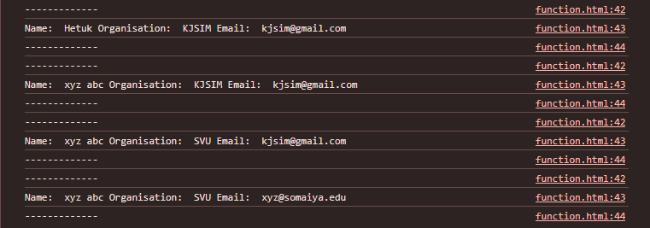
7. Generic Function

<!DOCTYPE html>
<html lang="en">
<head>
<script>
// 7. Generic Function
function sum(...num) {
var res = 0;
for (var i = 0; i < arguments.length; i++)
res += arguments[i];

return res;
}

console.log("Sum(11,22)= ", sum(11, 22));
console.log("Sum(11,22,33)= ", sum(11, 22, 33));
console.log("Sum(11,22,33,44,55,66,77)= ", sum(11, 22, 33, 44, 55, 66, 77));
</script>
</head>
<body>
</body>
</html>

Output:

8. Constructor Function
<!DOCTYPE html>
<html lang="en">
<head>
<script>
//8. Constructor Function
var mul = new Function('a','b','return a*b');

console.log("Mul(5,7): ",mul(5,7));
console.log("Mul(55,77): ",mul(55,77));
</script>
</head>
<body>
</body>
</html>

Output:

8.1. Constructor Function – Variation 2
<!DOCTYPE html>
<html lang="en">
<head>
<script>
//8. Constructor Function Variation 2
function Student(name, email, course) {
this.name = name;
this.email = email;
this.course = course;
}

var s1 = new Student("abc", "abc@gmail.com", "MCAFY");
var s2 = new Student("xyz", "xyz@gmail.com", "MCASY");

console.log("Name: ", s1.name, "Email: ", s1.email, "Course: ", s1.course);
console.log("Name: ", s2.name, "Email: ", s2.email, "Course: ", s2.course);
</script>
</head>
<body>
</body>
</html>

Output:

9. High Order Function
<!DOCTYPE html>
<html lang="en">
<head>
<script>
//9. High Order Function
// Function As A Parameter Or Function As Return Value

function getDiscount(fun, value) {
return fun(value)
}

const disc10 = (value) => value * 0.1;
const disc20 = (value) => value * 0.2;

console.log("10% Discounted Price: ", getDiscount(disc10, 45000));
console.log("20% Discounted Price: ", getDiscount(disc20, 45000));
</script>
</head>
<body>
</body>
</html>

Output:

10. Generator Function
<!DOCTYPE html>
<html lang="en">
<head>
<script>
//10. Generator Function
function* generateEmpid() {
var empid = 101;
while (true) {
yield empid;
empid++;
}
}

const checkEmpid = generateEmpid();

// console.log(generateEmpid().next().value); It will not work or give same value repeatedly
console.log(checkEmpid.next().value);
console.log(checkEmpid.next().value);
console.log(checkEmpid.next().value);
console.log(checkEmpid.next().value);
console.log(checkEmpid.next().value);

// function loop(){
// // Infinite Loop
// while (true) {
// console.log("Running Infinite Loop...");
// }
// }

// loop();
</script>
</head>
<body>
</body>
</html>

Output:
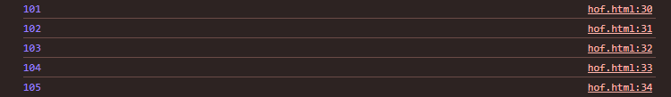

11. Callback Function
<!DOCTYPE html>
<html lang="en">
<head>
<script>
//11. Callback Function - Function As Parameter
function functionAsParameter(callback) {
console.log("Welcome To The functionAsParameter()");
return callback();
}

function wish() {
console.log("Good Day!");
}
</script>
</head>
<body>
<button onclick="functionAsParameter(wish)">CallBack Function</button>
</body>
</html>

Output:
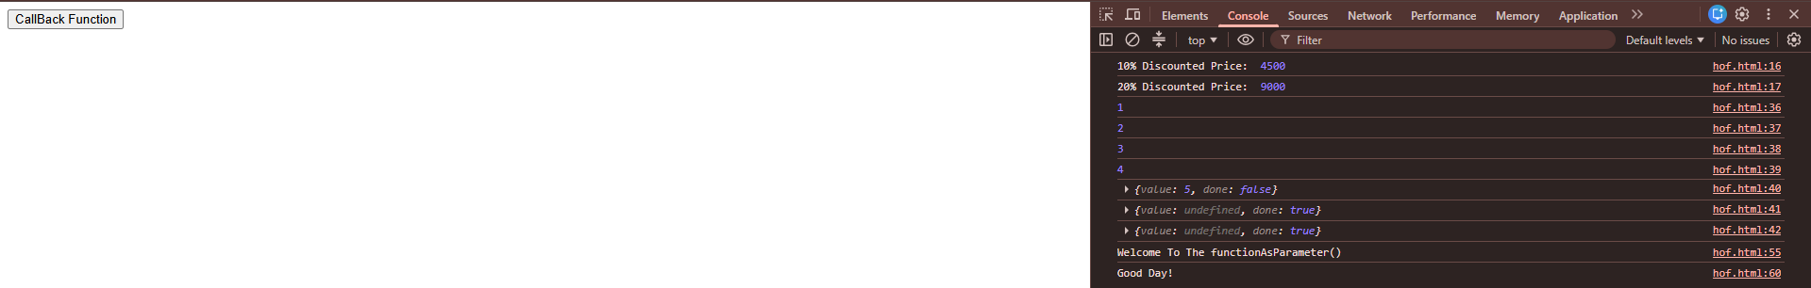

11.1 Callback Function – Variation 2
<!DOCTYPE html>
<html lang="en">
<head>
<script>
//11. Callback Function - Function As Parameter
function functionAsParameter(callback) {
console.log("Welcome To The functionAsParameter()");
return callback();
}

function functionAsParameterTO(callback) {
console.log("Execution Started");
console.log("Welcome To The functionAsParameter()");

setTimeout(callback, 3000)
// console.log("Welcome To The functionAsParameter()");
console.log("Execution Ended");
}

function wish() {
console.log("Good Day!");
}
</script>
</head>
<body>
<button onclick="functionAsParameterTO(wish)">CallBack Function2</button>
</body>
</html>

Output:
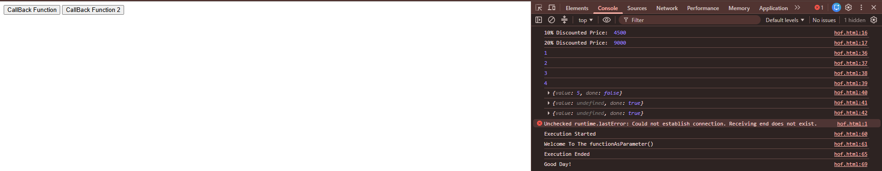

12. Async Function
<!DOCTYPE html>
<html lang="en">
<head>
<script>
function wish() {
console.log("Good Day!");
}

//12. Async Function
async function myFunction(callback) {
console.log("Welcome To Async Function!");

// await new Promise(resolve => setTimeout(callback, 3000))

setTimeout(callback, 3000)
setTimeout(callback, 1000)

console.log("Welcome To Async Function!");
}
</script>
</head>
<body>
<button onclick="myfunction(wish)">Async Function</button>
</body>
</html>

Output:
1. Function Declaration hoisting is supported

<!DOCTYPE html>
<html lang="en">
<head>
<script>
// Function
wish();

//1. Function Declaration hoisting is supported
function wish() {
console.log("Good Morning");
// }
</script>
</head>
<body>
</body>
</html>

Output:

2. Function Expression hoisting is not supported

<!DOCTYPE html>
<html lang="en">
<head>
<script>
wish();
//2. Function Expression hoisting is not supported
var wish = function () {
console.log("Good Morning");
// }
</script>
</head>
<body>
</body>
</html>
Output:

3. Arrow Function hoisting is not supported

<!DOCTYPE html>
<html lang="en">
<head>
<script>
wish();
//3. Arrow Function hoisting is supported
var wish = () => {
console.log("Good Morning");
}
</script>
</head>
<body>
</body>
</html>
Output:

Window Methods
1. SetTimeOut And SetInterval

<!DOCTYPE html>
<html lang="en">
<head>
<script>
// alert("Welcome To Windows!");
// window.alert("Welcome To Windows!");
// window.print()
// window.blur()
// window.focus()

// Executed Only Once And After 5 Seconds
setTimeout(()=>{console.log("setTimeout() called !!!");},5000);

// Executed Every 1 Second As Time Interval
setInterval(()=>{console.log("setInterval() called !!!");},1000);
</script>
</head>
<body>
</body>
</html>

Output:

2. ClearInterval

<!DOCTYPE html>
<html lang="en">
<head>
<script>
// Executed Only Once And After 5 Seconds
setTimeout(() => { console.log("setTimeout() called !!!"); }, 5000);

function settingInterval() {
document.getElementById("output").innerHTML = Date();
}

// Executed Every 1 Second As Time Interval
var timer;
function showTime() {
timer = setInterval(settingInterval, 1000);
}

function stopTime() {
clearInterval(timer)
}
</script>
</head>
<body>
<p id="output"></p>
<button onclick="showTime()">Check Date & Time</button>
<button onclick="stopTime()">Stop Date & Time</button>
</body>
</html>

Output:
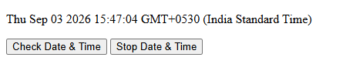
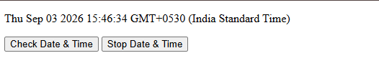

3. Window.Open
<!DOCTYPE html>
<html lang="en">
<head>
<script>
function urlOpen() {
window.open("https://www.google.com")
}

function urlSelf() {
window.open("https://www.google.com","_self")
}
</script>
</head>
<body>
<button onclick="urlOpen()">Google</button>
<button onclick="urlSelf()">Google Self</button>
</body>
</html>
Output:
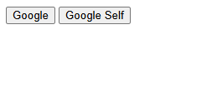
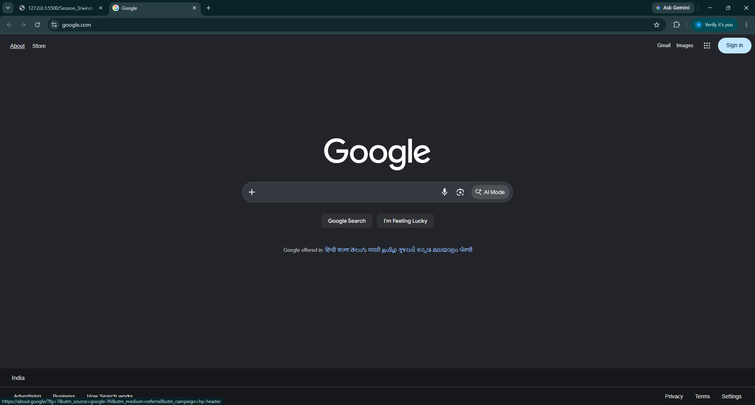

4. Window.Confirm

<!DOCTYPE html>
<html lang="en">
<head>
<script>
function getConfirm() {
if(window.confirm("Are You An MCA Student?"))
console.log("Welcome MCA Aspirant");
else
console.log("Invalid Identity");
}
</script>
</head>
<body>
<button onclick="getConfirm()">Confirm Here If MCA</button>
</body>
</html>
Output:
5. Window.Prompt
<!DOCTYPE html>
<html lang="en">
<head>
<script>
function doLogin() {
var name = window.prompt("Email: ")
var password = window.prompt("Password")

if (name == "hello@gmail.com" && password == "123")
alert("Login Succesful")
else
alert("Login Failed")
}
</script>
</head>
<body>
<button onclick="doLogin()">Confirm Here If MCA</button>
</body>
</html>

Output:

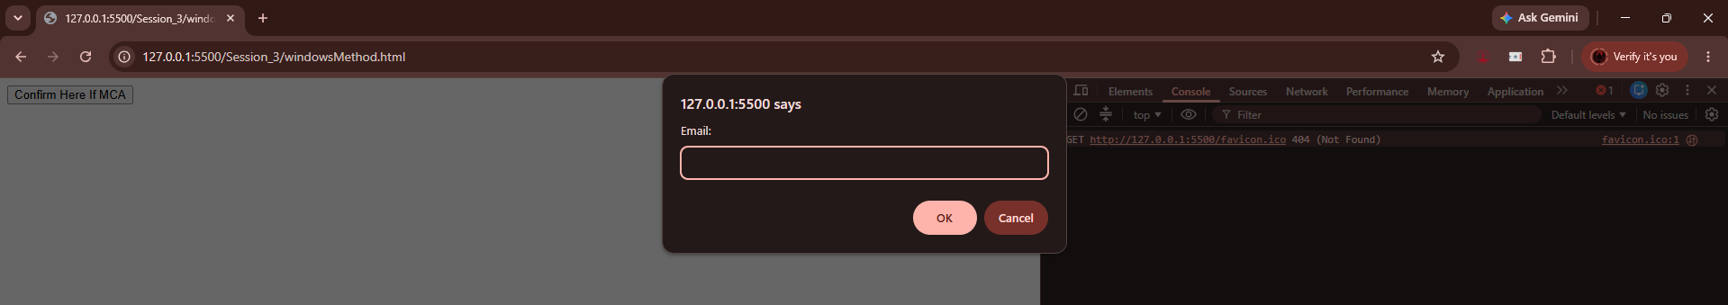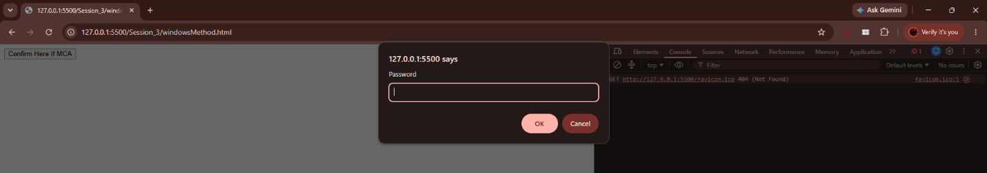
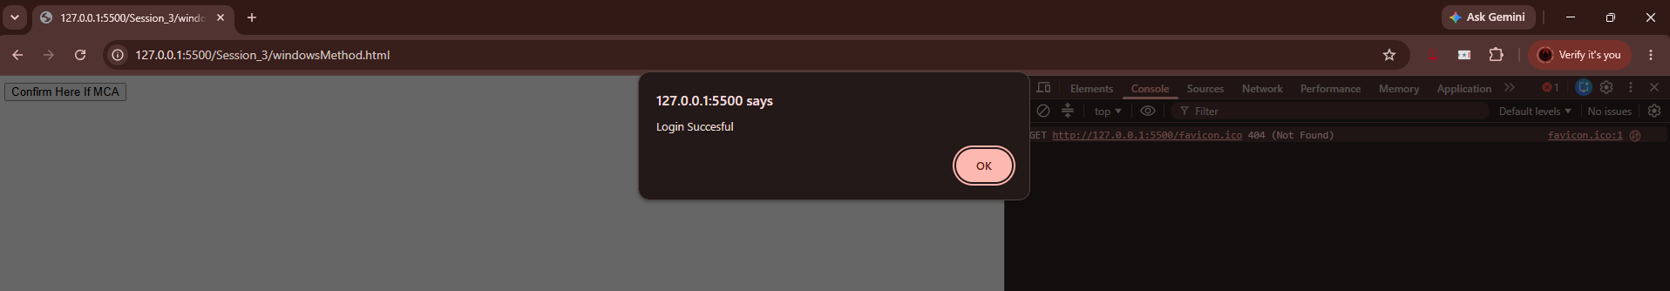
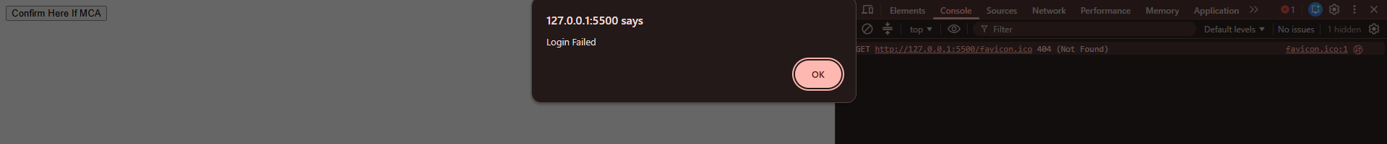

6. Focus And Blur
<!DOCTYPE html>
<html lang="en">
<head>
<script>
let myWindow = window.open("","myWindow","height:300,width:300")

function setFocus() {
myWindow.focus();
}

function letBlur(){
myWindow.blur();
}
</script>
</head>
<body>
<button onclick="setFocus()">SetFocus</button>
<button onclick="letBlur()">LetBlur</button>
</body>
</html>

Output:
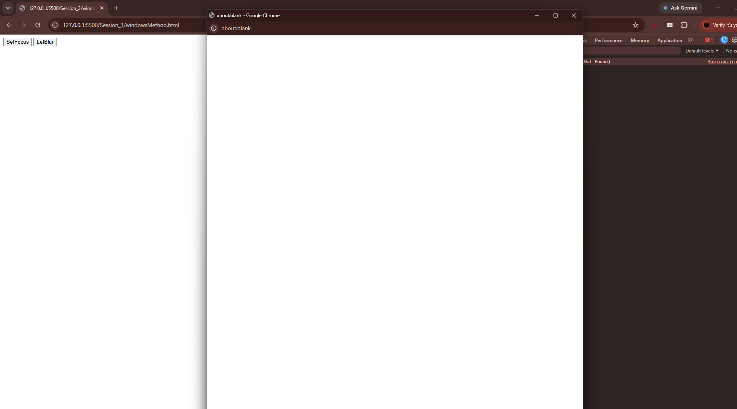
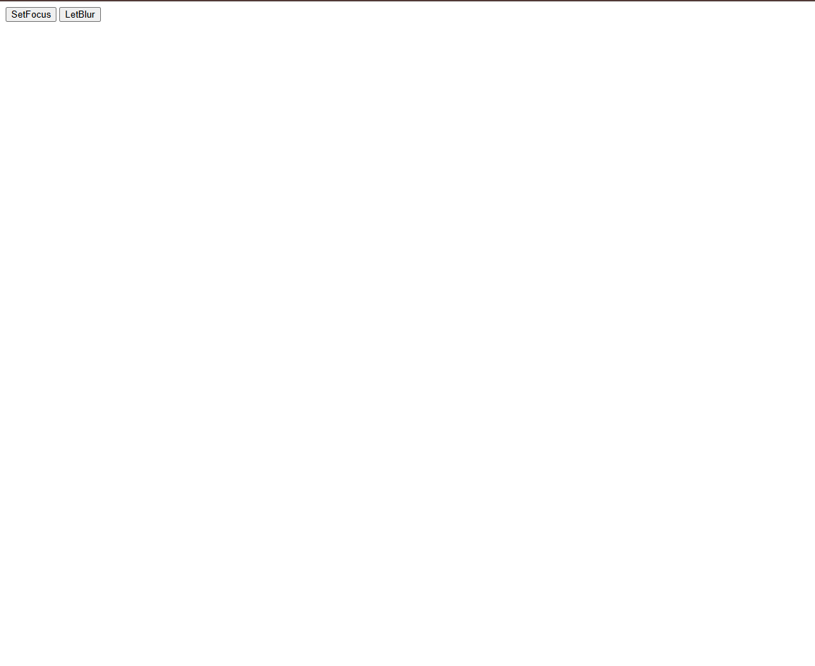
DOM (Document Object Model)

1. Get Element By ID
<!DOCTYPE html>
<html lang="en">
<head>
<script>
function doSomething(){
document.getElementById("output").innerHTML="Welcome"
}
</script>
</head>
<body>
<p id="output">Good Morning</p>
<button onclick="doSomething()">Do Something</button>
</body>
</html>

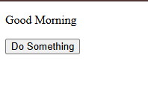
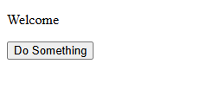
Output:
2. Get Element By Name
<!DOCTYPE html>
<html lang="en">
<head>
<script>
function doSomething(){
var abc = document.getElementsByName("first");
alert(abc);

abc.forEach(i=>console.log(i.innerText));
}
</script>
</head>
<body>
<p name="first">Hello</p>
<p name="first">Welcome</p>
<p name="first">Good Morning</p>
<button onclick="doSomething()">Name</button>
</body>
</html>

Output:
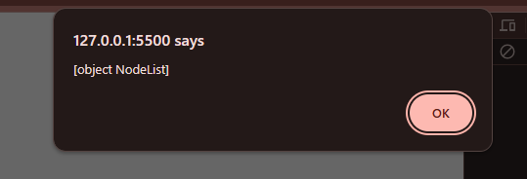

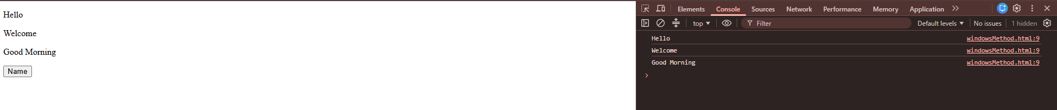

3. Get Element By TagName
<!DOCTYPE html>
<html lang="en">
<head>
<script>
function doSomething(){
var abc = document.getElementsByTagName("p");
alert(abc);

alert(abc.length);
for(let i=0;i<abc.length;i++){
abc[i].innerText="Heading" +i;
}
}
</script>
</head>
<body>
<p name="first">Hello</p>
<p name="first">Welcome</p>
<p name="first">Good Morning</p>
<button onclick="doSomething()">Name</button>
</body>
</html>

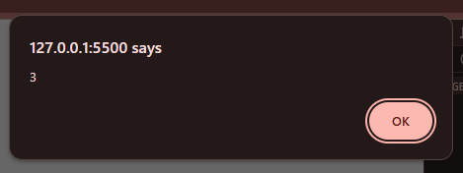
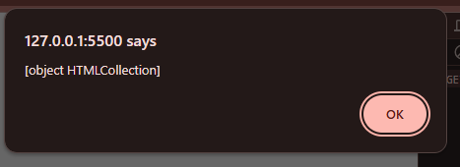
Output:
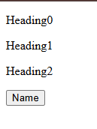

4. Query Selector
<!DOCTYPE html>
<html lang="en">
<head>
<script>
function checkSports() {
var sports = document.querySelector("#info").value;
document.getElementById("output").innerHTML = sports;
}
</script>
</head>
<body>
Name: <input type="text" id="info"><br><br>
Email: <input type="text" id="info"><br>
<p id="output"></p>
<input type="submit" value="submit" onclick="checkSports()">
</body>
</html>

Output:
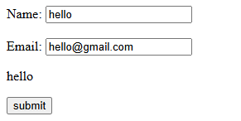
<!DOCTYPE html>
<html lang="en">
<head>
<script>
function checkSports() {
var sports = document.querySelector(".sports").value;
document.getElementById("output").innerHTML = sports;
}
</script>
</head>
<body>
<input type="radio" name="sports" value="cricket" class="sports">Cricket
<input type="radio" name="sports" value="football" class="sports">Football
<input type="radio" name="sports" value="squash" class="sports">Squash
<br>
<p id="output"></p>
<input type="submit" value="Submit" onclick="checkSports()">
</body>
</html>

Output:
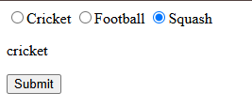

<!DOCTYPE html>
<html lang="en">
<head>
<script>
function checkSports() {
var sports = document.querySelector("input[type='radio']").value;
document.getElementById("output").innerHTML = sports;
}
</script>
</head>
<body>
<input type="radio" name="sports" value="cricket" class="sports">Cricket
<input type="radio" name="sports" value="football" class="sports">Football
<input type="radio" name="sports" value="squash" class="sports">Squash
<br>
<p id="output"></p>
<input type="submit" value="Submit" onclick="checkSports()">
</body>
</html>

Output:
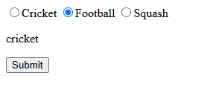
<!DOCTYPE html>
<html lang="en">
<head>
<script>
function checkSports() {
var sports = document.querySelector("h1").value;
document.getElementById("output").innerHTML = sports;
}
</script>
</head>
<body>
<h1>Hello</h1>
<h1>Good Morning</h1><br>
<p id="output"></p>
<input type="submit" value="Submit" onclick="checkSports()">
</body>
</html>

Output:
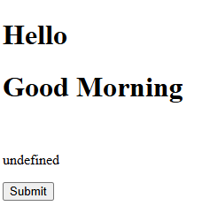
<!DOCTYPE html>
<html lang="en">
<head>
<script>
function checkSports() {
var sports = document.querySelector("h1").textContent;
var sports = document.querySelector("h1").innerHTML;
var sports = document.querySelector("h1").innerText;
document.getElementById("output").innerHTML = sports;
}
</script>
</head>
<body>
<h1>Hello</h1>
<h1>Good Morning</h1><br>
<p id="output"></p>
<input type="submit" value="Submit" onclick="checkSports()">
</body>
</html>

Output:
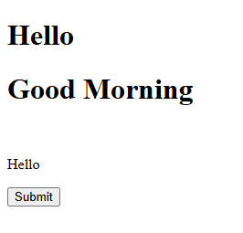
<!DOCTYPE html>
<html lang="en">
<head>
<script>
function checkSports() {
var sports = document.querySelector("input[type='radio']:checked").value;
document.getElementById("output").innerHTML = sports;
}
</script>
</head>
<body>
<input type="radio" name="sports" value="cricket" class="sports">Cricket
<input type="radio" name="sports" value="football" class="sports">Football
<input type="radio" name="sports" value="squash" class="sports">Squash
<br>
<p id="output"></p>
<input type="submit" value="Submit" onclick="checkSports()">
</body>
</html>

Output:
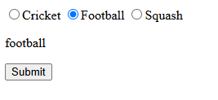
5. Query Selector All
<!DOCTYPE html>
<html lang="en">
<head>
<script>
function getInfo() {
var info = document.querySelectorAll("input");
info.forEach(
function(info){
document.getElementById("output").innerHTML+=info.value+"<br>";
}
);
info.forEach();
}
</script>
</head>
<body>
Name: <input type="text"><br><br>
Email: <input type="text"><br><br>
City: <input type="text"><br>
<br>
<p id="output"></p>
<input type="submit" value="Register" onclick="getInfo()">
</body>
</html>

Output:
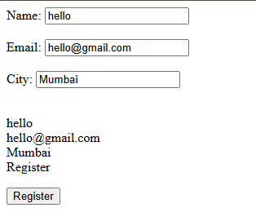

<!DOCTYPE html>
<html lang="en">
<head>
<script>
function getInfo() {
var info = document.querySelectorAll("input");

info.forEach(
function(info){
// alert(info.value);
document.getElementById("output").innerHTML+=info.value+"<br>";
}
);

var sports = document.querySelectorAll("input[type='checkbox']");
document.getElementById("output").innerHTML+="<br> You Play: ";
sports.forEach(
function(sports){
if(sports.checked)
document.getElementById("output").innerHTML+=sports.value + " ";
}
);
// alert();
}
</script>
</head>
<body>
Name: <input type="text"><br><br>
Email: <input type="text"><br><br>
City: <input type="text"><br>
<hr>
Which All Sports Do You Play:
<input type="checkbox" name="sports" value="table tennis">Table Tennis
<input type="checkbox" name="sports" value="badminton">Badminton
<input type="checkbox" name="sports" value="futsal">Futsal
<p id="output"></p>
<input type="submit" value="Register" onclick="getInfo()">
</body>
</html>

Output:
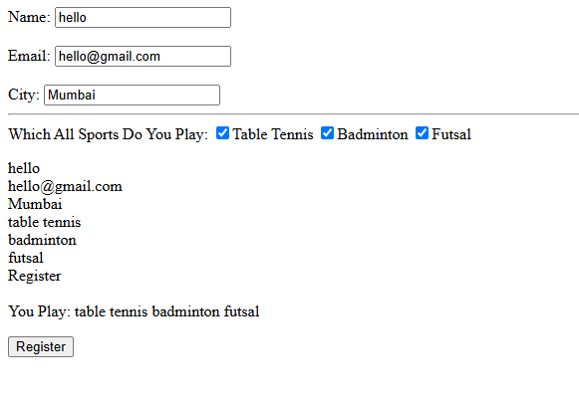
7. Changing Attributes Of An Element
<!DOCTYPE html>
<html lang="en">
<head>
<script>
function bulbOn(){
document.getElementById("bulb").src="./Utils/Bulb_On.avif";
console.log("Bulb On");
}
function bulbOff(){
document.getElementById("bulb").src="./Utils/Bulb.jpg";
console.log("Bulb Off");
}
</script>
</head>
<body>
<img src="./Utils/Bulb.jpg" style="width: 150px;" height="150px" id="bulb"/>
<br>
<button onclick="bulbOff()">Bulb Off</button>
<button onclick="bulbOn()">Bulb On</button>
</body>
</html>
OR
<!DOCTYPE html>
<html lang="en">
<head>
<script>
function bulbOn(){
const bulbImage=document.getElementById("bulb")
bulbImage.setAttribute("src","./Utils/Bulb_On.avif");
console.log("Bulb On");
}
function bulbOff(){
const bulbImage=document.getElementById("bulb")
bulbImage.setAttribute("src","./Utils/Bulb.jpg");
console.log("Bulb Off");
}
</script>
</head>
<body>
<img src="./Utils/Bulb.jpg" style="width: 150px;" height="150px" id="bulb"/>
<br>
<button onclick="bulbOff()">Bulb Off</button>
<button onclick="bulbOn()">Bulb On</button>
</body>
</html>

Output:
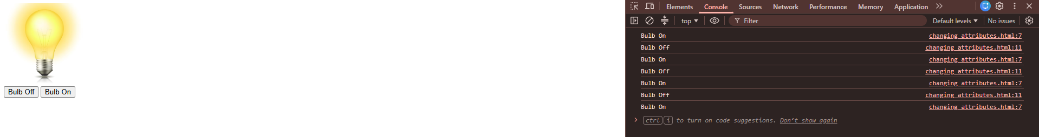
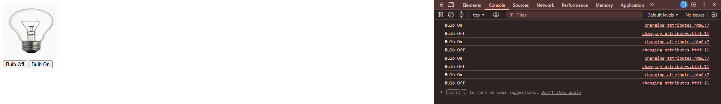
8. Create, Replace 1st and Remove Element
<!DOCTYPE html>
<html lang="en">
<head>
<script>
function createListItem(){
const mySubs=document.getElementById("mySubs");
const newList=document.createElement("li");
newList.innerText="New Item";
mySubs.appendChild(newList);
}
function replaceFirstListItem(){
const mySubs=document.getElementById("mySubs");
const repLi=document.querySelector("li");
const newList=document.querySelector("li");

newList.innerText="Replaced Item";
mySubs.replaceChild(repLi,newList);

}
function removeListItem(){
const mySubs=document.getElementById("mySubs");
const newList=document.querySelector("li");
mySubs.removeChild(newList);
}
</script>
</head>
<body>
<h1>My Subject List</h1>
<ul id="mySubs"></ul>
<button onclick="createListItem()">Create New List Items</button>
<button onclick="replaceFirstListItem()">Replace 1st Element</button>
<button onclick="removeListItem()">Remove Element</button>
</body>
</html>

Output:
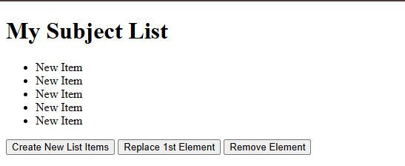
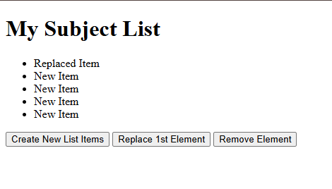
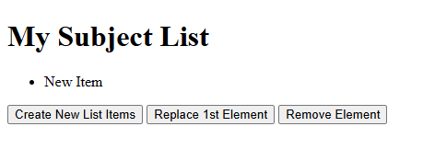

9. Create, Replace and Remove Element Dynamic

<!DOCTYPE html>
<html lang="en">
<head>
<script>
let idd = 0;
function createListItem(){
const mySubs=document.getElementById("mySubs");
const newList=document.createElement("li");
newList.setAttribute("id","item-"+idd);
idd+=1;
var uinput = document.getElementById("input").value;
newList.innerText = uinput;
mySubs.appendChild(newList);
}
function replaceFirstListItem(){
const mySubs=document.getElementById("mySubs");
const repLi=document.querySelector("li");
const item_id = document.getElementById("replaceId").value;
const replaceValue = document.getElementById("textReplace").value;
const newList=document.getElementById(item_id);
newList.innerText=replaceValue;
}
function removeListItem(){
const mySubs=document.getElementById("mySubs");
const removeElement = document.getElementById("removeId").value;
const removedElement = document.getElementById(removeElement);
mySubs.removeChild(removedElement);
}
</script>
</head>
<body>
<h1>My Subject List</h1>
Input: <input type="text" id="input"><br><br>
Item-Id: <input type="text" id="replaceId"><br><br>
Replace: <input type="text" id="textReplace"><br><br>
Remove Item-Id: <input type="text" id="removeId"><br><br>
<ol id="mySubs"></ol>
<br>
<button onclick="createListItem()">Create New List Items</button>
<button onclick="replaceFirstListItem()">Replace Element</button>
<button onclick="removeListItem()">Remove Element</button>
</body>
</html>

Output:
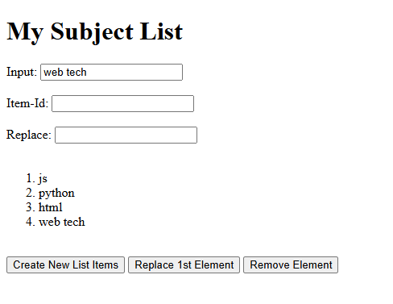

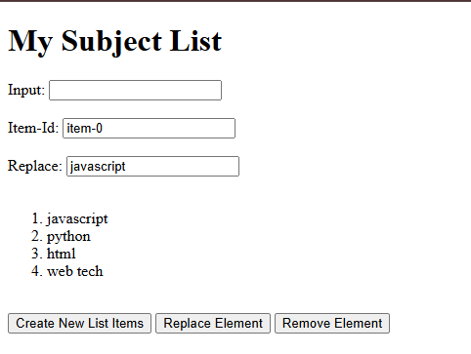

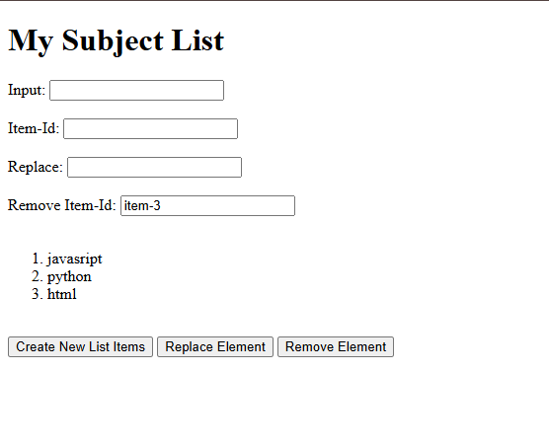

10. Event Handling On DOM Object
<!DOCTYPE html>
<html lang="en">
<head>
<title>Event Handling</title>
</head>
<body>
<!-- Event Handling In JavaScript -->
<!-- Inline -->
<button id="login1">Login1</button>
<button id="login" onclick="alert('This Is Inline Event Handling')">Login</button>
<script>
const btn = document.getElementById("login1")
btn.onclick = checkMsg();
function checkMsg(){
alert("Handling Event On DOM Object");
console.log("Handling Event On DOM Object");
}
function handleClick(){alert("Listner Called Another User Defined Function")}
btn.addEventListener("click",handleClick);
btn.addEventListener("click",(e)=>{alert("handling Event Through addEventListner 1st Time")});
btn.removeEventListener("click",handleClick);
</script>
</body>
</html>

Output:
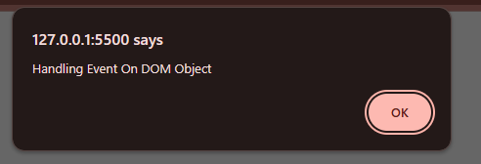

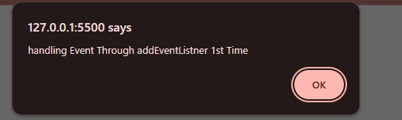

11. Custom Event
<!DOCTYPE html>
<html lang="en">
<head>
</head>
<body>
<input type="text" id="input"><br>
<ul id="myList"></ul>
<button onclick="additem()">Add Item</button>
<script>
const myList = document.getElementById("myList");
myList.addEventListener("itemAdded",(e)=>console.log("li item added",e.detail.text));
function additem(){
const li = myList.appendChild(document.createElement("li"));
li.textContent = document.getElementById("input").value;
li.dispatchEvent(new CustomEvent("itemAdded",{detail: {text :li.textContent}}));
}
</script>
</body>
</html>

Output:
